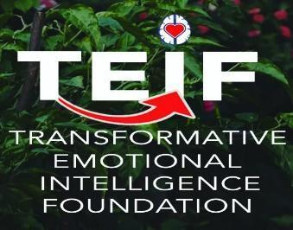


Skills for Career and Life Effectiveness (SCALE) ®
Informational Flyer
Introduction and Purpose: SCALE is a positive assessment process to explore, discover skill strengths and areas to further develop within Intrapersonal, Interpersonal, Career/Life, Personal Wellness, and Personal Change Dimensions. It is related to high achievement, leadership, mentoring, coaching, training & development. SCALE helps answer the question — What Is Your Communication Style Under Stress and Pressure? The SCALE identifies 11 key essential skills and 3 potential problematic areas to enhance, improve, strengthen, develop. Skills profile, changes needed, and comprehensive interpretation guide and behaviors to more fully develop are included in the instrument’s extensive and tailored feedback report.
Target Audience: Individuals and teams/groups within an academic, business, government, or other sector setting who are interested in further development (and possibly mentoring and coaching).
Instrument’s Focus: SCALE is the premier on-line positive assessment process to build engagement to identify individual/team needs. The SCALE systematically measures 11 essential skills necessary for career productivity, life growth, career transitions, personal change. It helps build rapport, respect, trust with an appreciative inquiry assessment and skills training. It is grounded on an accountability model, research design to objectively measure and help document the impact of training and education programs.
Applications: Mentoring, Coaching, Life/Career Development, Leadership Development, Training Needs Assessment
Value-Added Outcomes | Benefits | Applications: The SCALE results will help organizations focus on where training and other interventions would be value-added and generate a positive return on investment. Its use is optimized by using results in a way that will advance individual and collective growth, competence, and confidence.
Duration: The SCALE is efficient - it can be taken in about 20 minutes.
Platform: The SCALE assessment is taken online in a user-friendly platform.
Process: Easy, efficient, effective. See example below. When SCALE is completed, a SCALE Skills Profile is generated for the person. A key feature is a link for each skill area provides hours of further study, learning, development for each SCALE area measured. Additional coaching, training available for follow-up applications.

Instrument Purchased

Instrument Provided to Client(s)

Client(s) Complete Instrument

Report Generated and Sent to Primary Client

Optional Coaching to Interpret and Apply Results
Price: Cost effective. Bulk discounts for multi-person use and current clients. Contact us for pricing of SCALE assessments and information. Additional pricing options for coaching, training provided by credentialed TEIF/EILS coaches. Please see contact information below.
Payment Options: We have a user-friendly, efficient invoicing and payment process.
Psychometric Properties: Doctoral dissertations and other research confirmed the validity and reliability of the SCALE and its use for personal and professional development, team building, and leadership development. SCALE is credible with extensive research and uses nationally, regionally, globally in corporate, government, education, and non-profit organizations … including private and public sectors, high tech, financial, energy, public health, and more.
For More Information, Please Contact: contact@teifoundation.org

