
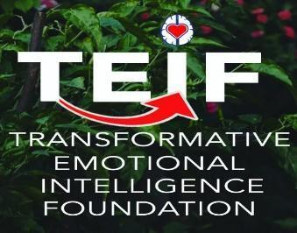

Personal Excellence Map (PEM) ®
Informational Flyer
Introduction and Purpose: The PEM is a researched derived on-line positive (strengths-based) assessment, empowering development system, and guide to help you achieve excellence in your personal and professional life. Excellence is intelligent self-direction to build knowledge, key skills, and personal wisdom guiding your best self in life and leadership.
In Transformative Emotional Intelligence (TEI) theory and practice, we discovered the essential puzzle pieces of excellence are guided by: a) how you think, b) how you manage your emotions, and c) how wisely you choose your behavior in problematic and challenging situations. As you embrace personal excellence, you need guide posts to make your journey meaningful and satisfying. Your PEM is an accurate roadmap you create to guide energy and an enduring commitment in developing yourself in positive ways toward excellence with trusted agents (e.g., peers, relatives, coaches).
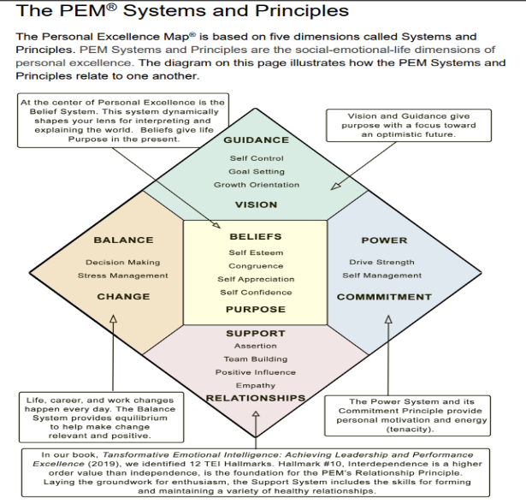
Target Audience: Adults at any level of their career who strive to sustain a healthy and authentic focus on personal and life excellence. Primary uses of the PEM include: personal excellence leadership, career development, leadership development, personal/team building, organizational focus on healthy workplaces, executive coaching. To date, the PEM has been extensively used in many of these arenas.
Instrument’s Focus: The pathway to excellence includes a clear vision (Guidance), a meaningful purpose (Beliefs), and goal directed energy (Power). Along the path of excellence, we will need help and guidance from others (Support) and specific skills to manage stress (Balance). See the companion visual.
Applications: By using this valid and reliable PEM instrument, you will gain a tremendous amount of informational feedback through a report generated from your self-assessment and, if provided in a multi-rater protocol, analyzed feedback offered from other raters. That information will provide both current state and user-friendly descriptions on specific actions to take in furthering your excellence journey.
Value-Added Outcomes & Benefits: In this dynamic talent marketplace, it is imperative to confidently know where you stand now in your excellence journey and the TEI principles you can use to continue life-long pursuits of increased trust, greater professionalism, improved quality of relationships, and fuel for achieving your goals. In an increasing AI era, it is more important than ever to remain true to your humanity and the connections that you build and sustain.
Duration: You and any other raters can complete the PEM in less than 20 minutes.
Platform: The PEM is available online with a customized link sent to you and any other raters you designate. Also, part of the pricing includes a free online course to help guide you through interpreting PEM results and taking next steps in your excellence journey.
Process: See illustration below. Reports are generated and sent to you and any other respondents within 30 minutes of completion.

Consultations and Instrument Purchased

Instrument Provided to Client(s)

Client(s) Complete Instrument

Report Generated and Sent to Primary Client

Optional Coaching to Interpret and Apply Results
Price: The per-user license is approximately $45. There are substantial bulk discounts for multi-person use, non-profit, academic, and for TEIF/EILS clients (in the $20-25/user range). The cost includes administering the PEM, generating/analyzing/providing written results, and customized feedback including way-forward recommendations. For an additional investment, we have expert facilitators who can facilitate team/organization developmental workshops and individual coaching sessions (in-person and virtually).
Payment Options: We have a user-friendly, efficient invoicing and payment process.
Psychometric Properties: Doctoral dissertations and other research confirmed the validity and reliability of the PEM and its use for professional and leadership development.
For More Information, Please Email us at: contact@teifoundation.org

